Health Training Specialists

Western Australia VET for Secondary Students Prospectus

- Auspice Provider
- CRICOS Provider
- Online Provider

22 Years Experience in Training
2022

Copyright Information

Copyright © 2020 Kingston Training and Employment Pty Ltd
Provider No 6811

Trading as:
- DNA Kingston Training

Copyright © 2020 Success Training Company Pty Ltd
Provider No 52256

Trading as:
- Dental Nursing Australia

All rights reserved. No part of this document may be reproduced, stored in a retrieval system or transmitted, in any form or by any means, electronic, mechanical, photocopying, recording, or otherwise, without prior written permission from Kingston Training and Employment Pty Ltd and Success Training Company Pty Ltd.

The author and the publisher of this learning information guide have endeavoured to provide correct information at the time of publication, though conditions and circumstances are variable. The author and the publisher disclaim any liability, loss or damage incurred directly or indirectly as a consequence of the use or application of any of the content of this learning information guide or of any person acting or refraining from action in reliance on any statement contained herein.

Auspice Provider & CRICOS Provider

DNA Kingston Training is registered on the Auspice Provider Panel for the Education Department and is CRICOS registered to provide training to International Students

Online Provider

DNA Kingston Training has the capability to provide Online learning with strong platforms. Face to face delivery real class time with Lecturing staff Online. Underpinning access for students to attain Power Points, Modules, Learner guides, Assessments, Videos and other resources as required Online.

RTO Name: | DNA Kingston Training, RTO No 6811 CRICOS 02899B  Registration ASQA from 1999 - 2025
RTO locations: | Belmont, Mandurah, Bunbury, Joondalup
Director: | Mrs Susan Lawton  susan@dnakingstontraining.edu.au
Contact details: | 1300855503 International: +61 8 94794865
RTO website URL | www.dnakingstontraining.edu.au
Email: | admin@dnakingstontraining.edu.au

Contents
Introduction 4
Delivery Methods 6
Training by DNA Kingston Training at the College or School 6
Auspicing arrangements at School with support 6
Other courses 6
Teachers’ qualifications, fees, days of delivery 7
Courses available for VET in School face to face Delivery 9
HLT35015 Certificate III in Dental Assisting 10
HLT45015 Certificate IV in Dental Assisting 11
HLT23215 Certificate II in Health Support Services 11
HLT33115 Certificate III in Health Services Assistance 13
HLT21015 Certificate II in Medical Service First Response 14
HLT35115 Certificate III in Dental Laboratory Assisting 15
HLT43015 Certificate IV in Allied Health Assistance 16
CHC33015 Certificate III in Individual Support 17
10585NAT Certificate III in Career Advancement……………………………………………………………………………18
Contact details 19
Perth city location: 18
Regional locations 18
Office hours 18
Contacts 18
Enrolment form……………………………………………………………………………………………………………………………….20

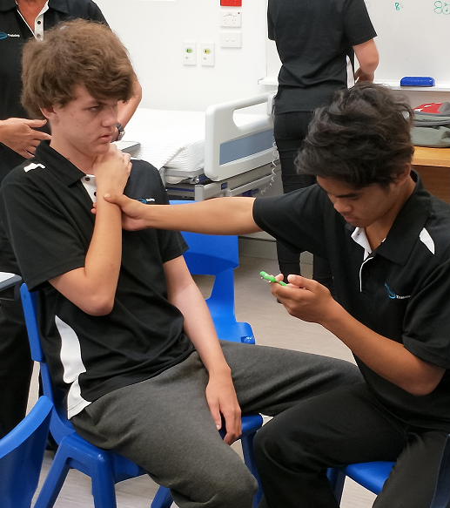

Introduction
Welcome to DNA Kingston Training, an award winning Registered Training Organisation in Western Australia, delivering nationally accredited courses. DNA Kingston Training offers a wide range of courses Certificate II level to Advanced Diplomas. Courses are available to both local and international students. Training is available through Part-time, Full-time and Correspondence delivery, with colleges located in Belmont, Bunbury and Mandurah. Australian Skills Quality Authority (ASQA) registration 1999-2025. Western Australian owned. CRICOS Registered for International Students.
Our organisation has been training since 1999 and is committed to the provision of quality Vocational Education and Training, establishing careers, securing employment and University pathways for further education. We are very proud of our recent achievement in being awarded WA International Training Provider of the Year in 2015 and Finalist in 2016. International Student of the Year 2016, finalist. Council of International Students of Western Australia, (CISWA) 2017 International Education Provider of the Year.
We have also previously won the Small Training Provider of the Year 2002 and Finalist 2003, 2004 (Commendation), 2005, 2007; and Finalist in the International Training Provider of the Year 2010, 2011 and 2014 at the Department of Training and Workforce Development Training Excellence Awards.
Why DNA Kingston Training? One of the reasons for our success is our unique collaboration and partnership between the industry, students and our wonderful talented Staff.
We endeavour to provide creative delivery and engaging learning by including in our Health and Dental courses: real practical health training in clinical environments, access to online learning with modules and power points, guest lectures, excursions to institutions and suppliers, First Aid, infection control, hand hygiene training, dental health education, and for those looking for a specific intro into Nursing – medical terminology, and a variety of general patient care units.
Pathways have been uniquely established with ECC (Edith Cowan College) on successful completion of the Certificate III in Health Services Assistance you attain direct offer and entry into the Diploma of Health Science of which articulates with Edith Cowan University Health Science & Nursing Degree programmes. You would enter into the second year of ECU. (Conditions apply with ECU entrance requirements).
The learning experiences which students receive are: challenging, rewarding, interesting, practical, total quality wrapped in a fun and friendly atmosphere. The courses are designed to include a variety of learning strategies to:
- individuals and group learning styles
- prepare you for your role as a member of a working team
- focus on the required practical skills for the qualification
Students from all over the world attend our programmes with a range of learning styles, needs and expectations. We commenced training VET for Secondary Students in 2012 and continue to teach school based students in our city and regional campuses. We endeavour to support and quality assure VET for Secondary Students programs being delivered in Western Australia. We are quality training focused, with the students and real industry outcomes as a priority.

New College and Head Office location 63 Abernethy Road Belmont 6104
Free Parking on site. Close access to Great Eastern Highway, Buses every 15 mins (Airport route)
Additional Information on courses and services
- Mid year intakes available
- Courses for long duration can commence Term IV or continue into Term IV
- First Aid
- Online learning capability as required
- COVID 19 Infection control training
Deliver Teacher Training of First Aid (1day) HLTAID006, HLTAID007 and HLTAID003. Can be one day on weekend or couple evenings – to complement this Provide training, industry currency, updates and PD twice a year. North and South.
-Provide certification for Students with First Aid the schools North and South.
Auspicing panel approved for Provide First Aid, Advanced First Aid, Cert III in Health Services Assistance, Cert II in Health Support Services, White card.

-Provide First Aid Training at the school with our own trainers for $90 student Minimum 10

White Card
Available at the school or at DNA Kingston Training colleges – Auspice arrangements are also available

Standard 1 day White card course $55 per student
2 day training with First Aid $195 per Student
Minimum numbers of 10 students

Try a Profession (TAP)
-Try a Profession (TAP) Year 9 &10 or 11 & 12 Students – 1 day (9.30 am to 2.30 pm), can bolt on First Aid and make into 2 -3 days. Bus is available to collect students as required.
The Health Profession will be the main target area, as they will have the highest employment requirement over the next 10 years.
Suggested areas: Nursing, Aged Care, Disabilities, Dental Assisting, Dental Technology, Dental Lab Assisting, Allied Health, Health Services Assistance, Health Support Services, WHS and in Health, Paramedics, medical administration.
Happy for Teaching Staff to participate in the day, practical hands on sessions, add First Aid if interested. Please contact Admin to arrange your sessions – sometimes a small Fees will apply to cover resources & materials for TAP practical activities and lunch if required. Currently no fees per student. Min Numbers 3. We are very proactive in supporting & engaging Students to the Health Professions.

Vocational Education & Training for Secondary Students (VETFSS)
Vet for Secondary Students is ideal for secondary students who are completing their WACE or Tertiary admissions subjects and wish to gain a practical skill in a specific industry and / or use the VET for Secondary Students as a pathway process to University.
You will attend the College one (1) day or (2) days a week for three to four school terms, depending on the course chosen, some courses do require mandatory work experience as part of the qualification (assistance provided). The programmes involve face to face classes, some assignment work at home, practical activities in a clinical environment, guest lectures and excursions. Modules and power points can be accessed on line for the Students convenience.
VET for Secondary Students expressions of interest and enrolments are now open, suggestion is to apply early, so you are not disappointed. Information can be obtained by email: admin@dnakingstontraining.edu.au
Ph:1300855503, website: www.dnakingstontraining.com.au or completing form on the back.

On successfully completing your course you will obtain a Certificate identifying you have completed a Nationally Recognized Qualification.
Some courses lead to entrance to University (Conditions do apply in English levels) or pathway colleges to University.

DNA Kingston Training is committed to high quality vocational programmes and has put in place an infrastructure that support successful and engaging study with social development for the young people studying VET programmes. We endeavour to be modern and responsive to Industry and Health professions needs.

Delivery Methods

Training by DNA Kingston Training at the College or School
Students attend face to face training at one of the DNA Kingston Training campuses (Bunbury, Mandurah and Belmont) or at a school based location. The Nationally Recognised Training programmes teach industry skills directly to students using our existing clinical training facilities.
We provide documentation / orientation for courses, course information, student handbook, training and assessment strategy, evidence mapping, physical resources, learning modules, assessment material and task, dedicated lecturers and assessors on site or off site of school, Assist work experience placements, arrange guest lectures / excursions, on line access.

Auspicing arrangements at School with support
Under an Auspice Model, all the training and assessment is undertaken by the school. DNA Kingston Training ensures that the training and assessment that the school undertakes meets the requirements of the Standards by the regulators (ASQA). DNA Kingston Training issues the qualifications and/or Statements of Attainment. It involves a number of stages of assessing school capabilities, proposed lecturers competencies, orientation and preparation of the training programme. DNA Kingston Training are currently registered on the panel with the Education Department to deliver Auspicing to Government schools in Western Australia.
Auspice can be provided in: Certificate III in Health Services Assistance, Certificate II in Health Support Services, White card, Provide First Aid, Advanced First Aid, Advanced Resuscitation.

Online learning available for all courses delivered, face to face real time, online learning as well as uploading information and accessing Power points, Videos, Assessments, Modules and Learner guides.
Other courses
English as a second language - additional support service available for English and Numeracy enhancement.
Numerous short courses can be customized to schools needs eg: “Job Ready programmes”. Include: First Aid, Safety cards (White card), WHS safety in the workplace, Infection control etc.
Units can be selected from other specific courses. All courses are Nationally Recognized.
We have the Staff and flexibility to add additional courses to our scope, to provide additional customized programmes and services for schools when required.

Teachers’ qualifications
All trainers and assessors are required to have:
- Certificate IV in Training and Assessment TAE40116 or equivalent;
- Vocational competency, at least to the level being delivered and assessed;
- Current industry skills directly relevant to the training and assessment being provided; and
- Current knowledge and skills in vocational training and learning that informs their training and assessment.
FEES
Fees for training in VET for Secondary Students is paid by the parents, who generally pay the fees to the Government school their child is enrolled. Private school Parents may find they pay DNA Kingston Training direct. Payment plans can be arranged for these parents. Some schools may wish to provide some tuition fee support towards training for Parents, which may reduce the fee structure. DNA Kingston Training has maintained the fees to a minimum, endeavouring not to compromise the quality of the training. Resource fees include: uniforms, books, materials, online access and modules.
DAYS OF DELIVERY
Thursdays and Fridays are the most popular days for delivery for the secondary schools and we endeavour to make these days available, however we are available for VET for Secondary Students training other days of the week, providing schools and students with more opportunities.
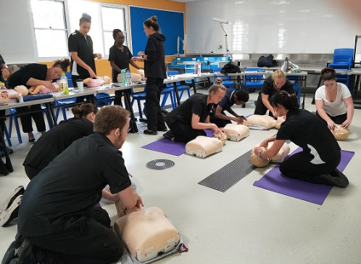

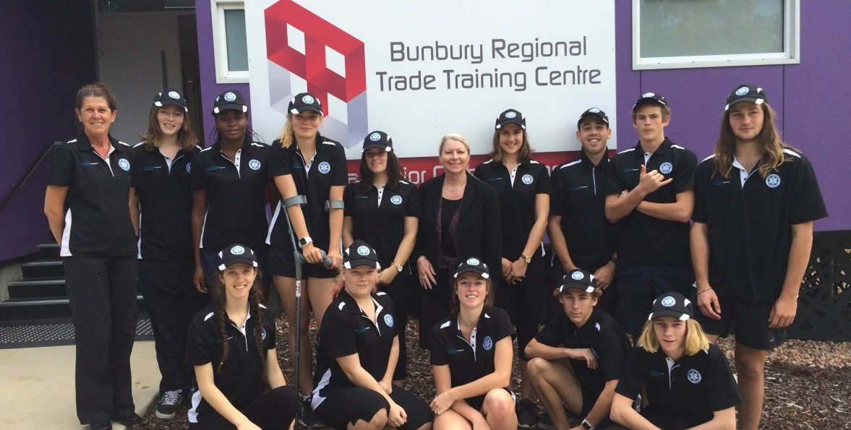
VET for Secondary Students at the BRTTC Bunbury Campus

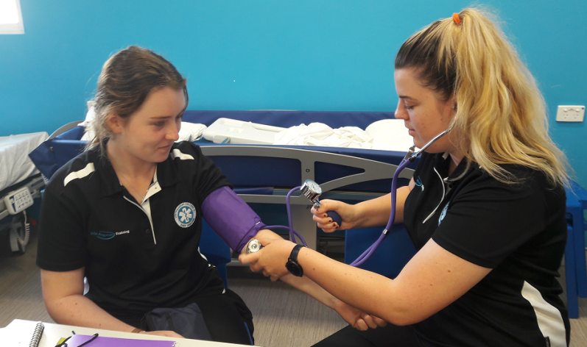
VET for Secondary Students involved in the Certificate II Medical Services First Response

VETiS Students completing their Apply First Aid Certificate

Courses available for VET for Secondary students face to face Delivery
DENTAL
Course Code | Course Name
HLT35015 | Certificate III in Dental Assisting + -250 hrs work experience
HLT45015 | Certificate IV in Dental Assisting ** -250 hrs work experience
HLT35115 | Certificate III in Dental Laboratory Assisting
HEALTH CARE
Course Code | Course Name
HLT23215 | Certificate II in Health Support Services – Recommended Year 11
HLT33115 | Certificate III in Health Services Assistance – Recommended for Year 12
HLT43015 | Certificate IV in Allied Health Assistance **, # - 120 hrs work experience
CHC33015 | Certificate III in Individual Support (Aged Care / Disability) - 120 hrs work experience
HLT43015 | Certificate IV in Ageing Support (Aged Care) – 120 hrs work experience - coming
FIRST AID – PARAMEDICAL
Course Code | Course Name
HLT21015 | Certificate II in Medical Service First Response
HLT41115 | Certificate IV in Health Care
Career Enhancement / Direction
Course Name
10585NAT Certificate III in Career Advancement
Certificate III in Health Services Assistance on completion has direct unique entry pathway to Edith Cowan College (ECC) to enter the Diploma of Science with a pathway into second year ECU.
Certificate III in Health Services Assistance on completion are also eligible for a number of Certificate IV Health related programmes at DNA Kingston Training with pathway entry to University.

DNA Kingston Training is also looking at creating future pathways in Diploma Nursing and Health Sciences with Notre Dame University for our Graduates.
** Available as VET for School Students course over 7 terms (students must commence in Year 11).
# Available as VET for School Students Traineeship
+ Available as VET for School Students face to face course and Traineeship
General Training Scope: Broad range of programmes available to the General Public and International Students including the above. Please see our web site for further information www.dnakingstontraining.edu.au
Courses include: Business and leadership, Work Health and Safety, Aged Care and Disability / Individual support, Emergency first response, Paramedic, Health Care, Dental Technology, Dental Assisting, Dental Laboratory Assisting, Health Services Assistance, Health auxiliary.
Secondary International Student programmes available, funding available through the Department of Training and Workforce Development (DTWD) for general public (local) students. (Conditions apply)
Online learning available as required. 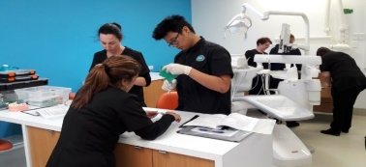

HLT35015 Certificate III in Dental Assisting
COURSE DESCRIPTION
Students will learn the skills to be a professional health worker as a Dental Assistant who assist a Dentist, Dental Hygienist or a Dental Therapist during oral health care procedures. Their role includes reassuring the patients, mixing dental materials, and setting up for dental procedures, passing instruments, maintaining high standards of infection control and assisting with practice administration in the dental sector. The course is conducted over 2 years with work experiences components embedded in the course.

PRE-REQUISITES
There are no other pre-requisites for this course. Course conducted over 2 years. Students entering course in Year 12 will be required to complete training in the following year and different fees may apply for 2nd year units. Work experience is required to complete this course. DNA Kingston Training will make every effort to assist students in finding work placements, as we have a strong connection with the Dental Profession over 20 years.

WHY CHOOSE THIS COURSE
This course is ideal for students who enjoy caring for people and prefer practical training. DNA Kingston Training is a multi-award winning training organisation specialising in Dental and Health training. This hands on course is taught by fully qualified lecturing staff with dental industry experience, providing students with up to date training and techniques.

EXAMPLES OF EMPLOYMENT/CAREER OPPORTUNITIES:
Career options include Dental Assistant (Nurse), Sterilization Nurse and Dental Receptionist. Employment options around the State are excellent in this health sector.

PATHWAYS FROM THE QUALIFICATION
Some units completed in this course will provide credit towards HLT45015 Certificate IV in Dental Assisting and other courses in the Health Training package.

COST/FEE PAYMENT OPTIONS:
Resource fees include: course modules, text book, uniforms. Payment plans available for direct payments.
Fees are paid to the Government school you attend, unless a private school who pay direct to the College.

SITE | FEES | RESOURCE FEES | COURSE DURATION | RTO | W/E HOURS REQUIRED
Belmont  Mandurah  Bunbury | $3,995 | $495  Books and uniforms | 2 days week over 6 terms  (2 years) or 1 day a week, commitment through the breaks. | DNA Kingston Training  Provider No. 6811 | To achieve this qualification, the student must complete at least 250 hours of work experience.
Contact us
P 1300 855 503 |E admin@dnakingstontraining.edu.au| W www.dnakingstontraining.edu.au

HLT45015 Certificate IV in Dental Assisting
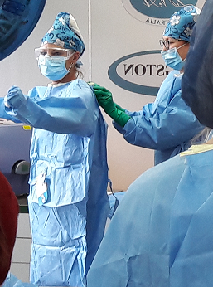
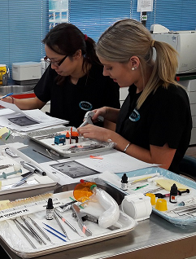
COURSE DESCRIPTION
Students will learn the skills to be dental assistant who provide an advanced level of assistance to a Dentist, Dental Specialist, Dental Hygienist or Dental Therapist, which contributes to the quality of oral health care. Their role includes: reassuring the patients, mixing dental materials, preparing for procedures, passing instruments, maintaining high standards of infection control. Additional advanced skills are attained in Orthodontics, Oral Surgery Dental Health Education and certain practice management skills for the dental sector. The course is conducted over 2 years with work experiences embedded in the course.

GENERAL INFORMATION
Course is conducted over 2 years. Recommended over year 11 and 12. Students entering course in Year 12 will be required to complete training after completing the school year, different fees may apply for 2nd year units. 250 hours work experience is required to complete this course. DNA Kingston Training will make every effort to assist students in finding work placements, as we have a strong connection with the Dental Profession over 20 years.
WHY CHOOSE THIS COURSE
This course is ideal for students who enjoy working with people looking for an interesting practical course that involves working, caring and managing people. Considering a career in Dental Assisting is an ideal choice with work opportunities in both the Government and Private sectors. DNA Kingston Training is a multi-award winning training organisation specialising in Dental and Health training. Students are taught by fully qualified lecturing staff. DNA Kingston Training work closely with the dental profession ensuring students are informed with the latest science and technologies. Additional hours through breaks may be required to achieve the work experience, with our support.
EXAMPLES OF EMPLOYMENT/CAREER OPPORTUNITIES:
Career options include Dental Assistant (Nurse), Dental Health Educator, Practice Management , Practice coordinator, Specialist Dental Assistant, Dental Sales Representative and Dental Receptionist. Employment in this sector is excellent with the Certificate IV qualification.
PATHWAYS FROM THE QUALIFICATION
Students can consider upskilling by completing the Certificate III in Dental Lab Assisting, Certificate IV in Aged Care (Dental Auxiliary Specialist), and Apprenticeship in Dental Technology or Business courses to enhance their Administration /Management skills. A Certificate IV in Dental Assisting will provide pathway entry directly to University, though English conditions do apply.
COST/FEE PAYMENT OPTIONS:
Resource fees include: course modules, text book, uniforms. Payment plans available for direct payments.
Fees are paid to the Government school you attend, unless a private school who pay direct to the College.

SITE | FEES | RESOURCE FEES | COURSE DURATION | RTO | W/E HOURS REQUIRED
Belmont  Mandurah  Bunbury | $4,595 | $495  Books and uniforms | 2 days week over 6 terms (2 years) + | DNA Kingston Training  Provider No. 6811 | To achieve this qualification, the student must complete at least 250 hours of work experience
Contact us
P 1300 855 503 |E admin@dnakingstontraining.edu.au |W www.dnakingstontraining.edu.au

HLT23215 Certificate II in Health Support Services
COURSE DESCRIPTION
Students will learn the role of Health Workers who provide support for the effective functioning of health services. At this level workers complete tasks under supervision. They support Health Workers in routines and procedures or complete routine procedures. Variable tasks are available in the health sector in collaboration with working with others in a team environment.
Course includes: Intro to medical terminology, infection control, communication, WHS, First Aid, Working effectively in the health environment. Provides a broad view of the Health sector and what it has to offer.

WHY CHOOSE THIS COURSE
This course is suitable for people wishing to pursue a career in the health care environment or a pathway to further studies within health. This qualification generally work in roles within a hospital or aged care facility. DNA Kingston Training is a multi-award winning training organisation specialising in Health training. Students are taught by fully qualified lecturing staff with industry experience providing students with relevant training. We work closely with each student, customising training for the individual.

EXAMPLES OF EMPLOYMENT/CAREER OPPORTUNITIES:
Career options include
- Admissions clerk,
- Ward assistant,
- Ward clerk,
- Client assistant

PATHWAYS FROM THE QUALIFICATION
Student can continue study in HLT33115 Certificate III in Health Services Assistance. The units completed in this course may provide credit towards a range of Health qualifications, allowing students continue with their health training. Ideally students in year 11 complete Cert II Health Support Services and enter into Cert III in Health Services Assistance to complete in year 12, then are offered a position in the pathway to ECC- Diploma of Health Science-ECU.

COST/FEE PAYMENT OPTIONS:
Resource fees include: course modules, text book, uniforms. Payment plans available for direct payments.
Fees are paid to the Government school you attend, unless a private school who pay direct to the College.

SITE | FEES | RESOURCE FEES | COURSE DURATION | RTO | W/E HOURS REQUIRED
Belmont  Bunbury  Mandurah | $2,200 | $190  Modules and uniforms | 1 day week over 3 terms | DNA Kingston Training  Provider No. 6811 | There are no work experience requirements for this course.
Contact us
P 1300 855 503 |E admin@dnakingstontraining.edu.au |W www.dnakingstontraining.edu.au

HLT33115 Certificate III in Health Services Assistance
COURSE DESCRIPTION
This qualification reflects the role of a variety of workers who use a range of decisions, practical procedures and knowledge to provide assistance and support to health professional staff for the care of patients. Health Services Assistance involves working with patients directly under supervision in a wide variety of health fields. This course is practical and endeavours to highlight the wide range of health sectors available to gain a career. Students will attain comprehensive knowledge in infection control, communication, working with colleagues in the health sector, WHS, medical techniques, moving patients, patient observations, medical communication.
WHY CHOOSE THIS COURSE
A Health Services Assistant is typically someone who is caring and trained ready to provide practical assistance to health professional staff for the care of patients. You provide hands on support and make decisions on patient care. Rewarding career for those who are looking to enter the Health Profession on a higher level and are looking for career pathways.
Students also undertake preparation for Nursing in this course which includes though not limited to: Medical Terminology and techniques, Infection control, working and communicating in a Medical environment and First Aid (First Response) are taught by fully qualified lecturing staff with industry experience. This is a practical course and lecturing staff work closely with each student.
DNA Kingston Training is a multi-award winning training organisation specialising in Health training
EXAMPLES OF EMPLOYMENT/CAREER OPPORTUNITIES:
- Nursing Assistant - Patient Care Assistant
- Nursing Support Worker - Patient Service Attendant - Orderly and Ward Assistant.
PATHWAYS FROM THE QUALIFICATION
Students can enter the Diploma of Health Science course and receive a direct offer to Edith Cowan College from DNA Kingston Training on successful completion of the Cert III in Health Services Assistance. Year 11 or year 12 General English with a 50% pass will also be required. (ATAR English is not required).
Complete the first and second year Diploma of Health Science at ECC (Edith Cowan College) which is equivalent to 1st year ECU (Edith Cowan University) – Students if accepted into ECU, go straight into second year at ECU after they complete the Diploma.
There are different streams that are available in the Health Sciences – Nursing, Psychology, and Biological science. There are also many areas of Health to pursue – Paramedic, Physiotherapy, Pharmaceutical, Health promotion etc.
Students can also consider completing HLT43015 Certificate IV in Allied Health Assistant or other courses from the Health Training package. The units completed in this course may provide credit towards a range of Health qualifications from Certificate III level and above, allowing students to continue with their health training.
COST/FEE PAYMENT OPTIONS:
Resource Fees include: course modules, text book, uniforms. Payment plans available for direct payments.
Fees are paid to the Government school you attend, unless a private school who pay direct to the College.
SITE | FEES | RESOURCE FEES | COURSE DURATION | RTO | W/E HOURS REQUIRED
Belmont  Bunbury  Mandurah | $2,300 | $190 Modules and uniforms | 1 day week over 3 terms | DNA Kingston Training  Provider No. 6811 | There are no work experience requirements for this course.
Contact us
P 1300 855 503 |E admin@dnakingstontraining.edu.au |W www.dnakingstontraining.edu.au

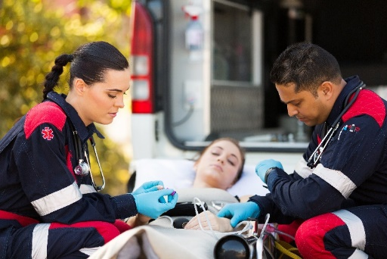
HLT21020 Certificate II in Medical Service First Response
COURSE DESCRIPTION
Students will learn the role of first medical response workers or volunteers who provide initial care to patients. These people provide basic First Aid and emergency responses in the pre-hospital/out of hospital environment.

PRE-REQUISITES
There are no pre-requisites for this course however it is recommended that students have sound literacy and numeracy skills.
WHY CHOOSE THIS COURSE
This course is ideal for students considering a hands on practical course and looking for a career in First Aid or Ambulance work. DNA Kingston Training is a multi-award winning training organisation specialising in Health training. Students are taught by fully qualified lecturing staff with Paramedic and First Aid industry experience providing students with relevant training. We work closely with each student, customising training for the individual. Scenarios, roll playing in a clinical environment, guest lectures and excursions are all part of the training, with the latest equipment.
EXAMPLES OF EMPLOYMENT/CAREER OPPORTUNITIES:
- Community based first responder
- Emergency medical responder (Mining sector)
- Workplace first responder
- Volunteer first aider

PATHWAYS FROM THE QUALIFICATION
The units completed in this course may provide credit towards a range of qualifications from Certificate III level and above, allowing students to continue with their First Aid / Health training.
DNA Kingston Training has developed a specific pathway with Certificate II in Medical Service First Response year 11 then onto Certificate IV in Health Care for year 12, with the Diploma in Paramedic Science available from there and onto University entrance second year ECU Paramedicine.
Students receive 7 unit credit continuing onto the Certificate IV in Health Care into year 12
COST/FEE PAYMENT OPTIONS:
Resource fees include: course modules, text book, uniforms. Payment plans available for direct payments.
Fees are paid to the Government school you attend, unless a private school who pay direct to the College.
.

SITE | FEES | RESOURCE FEES | COURSE DURATION | RTO | W/E HOURS REQUIRED
Belmont  Bunbury (BRTTC)  Mandurah  Joondalup | $1,900 | $160  Modules and uniforms | 1 day / week over 3 terms | DNA Kingston Training  Provider No. 6811 | There are no work experience requirements for this course.
Contact us
P 1300 855 503 |E admin@dnakingstontraining.edu.au |W www.dnakingstontraining.edu.au

HLT35115 Certificate III in Dental Laboratory Assisting
COURSE DESCRIPTION
Students will learn the role of a dental laboratory assistant who are responsible for pouring impressions, producing custom-made trays, manufacturing occlusal registration rims, transferring oral records, articulating models for a range of prosthesis, and constructing mouth guards.

PRE-REQUISITES
There are no pre-requisites for this course

WHY CHOOSE THIS COURSE
This course is ideal for students who wish to work in the Health sector and who like practical, manual work, working with their hands. Dental Laboratory Assisting is an ideal course to enter the Dental Profession. DNA Kingston Training is a multi-award winning training organisation specialising in Health training. Students are taught by fully qualified lecturing staff with dental industry experience providing students with up to date training and techniques. We work closely with each student, customising training for the individual.

EXAMPLES OF EMPLOYMENT/CAREER OPPORTUNITIES:
Dental Laboratory Assistants work alongside Dental Technicians in a Dental Laboratory to assist in the production of dental prosthetics (artificial dental appliances) for dental patients. They will be exposed to the real workplace and fabricating appliances.

PATHWAYS FROM THE QUALIFICATION
Students can consider completing the Certificate IV in Dental Assisting to broaden employment outcomes, or an Apprenticeship in Dental Technology. Employment options in this sector are strong within the pathways.

COST/FEE PAYMENT OPTIONS:
Resource fees include: course modules, text book, uniforms. Payment plans available for direct payments.
Fees are paid to the Government school you attend, unless a private school who pay direct to the College.
.

SITE | FEES | RESOURCE FEES | COURSE DURATION | RTO | W/E HOURS REQUIRED
Bunbury  Belmont | $1,990 | $145 | 1 day / week over 3 terms | DNA Kingston Training  Provider No. 6811 | There are no work experience requirements for this course.
Contact us
P 1300 855 503 |E admin@dnakingstontraining.edu.au |W www.dnakingstontraining.edu.au
HLT43015 Certificate IV in Allied Health Assistance COURSE DESCRIPTION
This course is a medical / health care based programme in preparation to assist professional health workers in providing therapeutic services to their patients.
This course is ideal for students considering a practical course and looking for a career in high level health care or looking for pathways to University in Health Science /Nursing programmes.
WHY CHOOSE THIS COURSE
This qualification is for individuals who demonstrate a natural empathy and are caring individuals who have quite often completed the Certificate III in Health Services Assistance This qualification reflects the role of workers who provide therapeutic and program related support to allied health professionals. The worker is required to conduct therapeutic and program related activities under the guidance of an allied health professional. Supervision may be direct, indirect or remote and must occur within organisation requirements. The worker is required to identify client circumstances that need additional input from the allied health professional. The worker may be engaged to work in a specialty area or work generically across the organisation in delivery of allied health assistance services. The worker, in conjunction with the allied health professional, may have responsibility for supervising other allied health assistance workers. You will find you are working with the patient directly.
To achieve this qualification, the candidate must have completed at least 120 hours of work experience.
EXAMPLES OF EMPLOYMENT/CAREER OPPORTUNITIES:
Assistant in Radiography, Physiotherapy, Psychology and other health professional areas.
Further educational pathways into Degree courses at ECU such as Nursing, Psychology, and Paramedic etc. may be available, conditions apply.
COURSE OVERVIEW
This course is ideal for students considering a practical course and looking for a career in high level health care or looking for pathways to University in Health Science / Nursing programmes. DNA Kingston Training is a multi-award winning training organisation specialising in Health training. Traineeships are available for this qualification.
EXAMPLES OF EMPLOYMENT/CAREER OPPORTUNITIES/PATHWAYS
Assistant in Radiography, Physiotherapy, Psychology and other health professional areas.
Further educational pathways into Degree courses at ECU such as Nursing, Psychology, and Paramedic etc. may be available, conditions apply. The units completed in this course may provide credit towards a range of qualifications from Certificate IV level, with direct entrance to some University Health Science programmes (English conditions may apply).
COST/FEE PAYMENT OPTIONS:
Resource fees include: course modules, text book, uniforms. Payment plans available for direct payments.
Fees are paid to the Government school you attend, unless a private school who pay direct to the College.
SITE | FEES | RESOURCE FEES | COURSE DURATION | RTO | W/E HOURS REQUIRED
Belmont  Bunbury (BRTTC)  Mandurah | $3,150  HSA credit $2,600 | $190  Modules and uniform | 1 day / week over 6 terms or  2 days, 3 terms Y12 +  Term breaks or 1 day, 3 Terms + term breaks | DNA Kingston Training  Provider No. 6811 | 120 hrs of work experience requirements for this course.

CHC33015 Certificate III in Individual Support (Community or Disability streams)

COURSE DESCRIPTION
This course provides participants with the skills and knowledge to work in the community and/or residential setting who follow an individualised plan to provide person-centred support to people who may require support due to ageing, disability or some other reason. Work involves using discretion and judgement in relation to individual support as well as taking responsibility for your own outputs. Workers have a range of practical skills, procedural knowledge, as well as some theoretical knowledge regarding the concepts and practices required to provide person-centred care and support.

WHY CHOOSE THIS COURSE
The course is recommended for people with a caring and patient nature who are seeking a rewarding career in caring for the people with disabilities, the elderly or people requiring individual support in their homes. DNA Kingston Training is a multi-award winning training organisation specialising in Health training. Students are taught by fully qualified lecturing staff with industry experience providing students with up to date training and techniques. We work closely with each student, customising training for the individual.

EXAMPLES OF EMPLOYMENT/CAREER OPPORTUNITIES:
Career options include Accommodation Support Worker, Personal Care Giver and Respite Care Worker in the home or with institutions.

PATHWAYS FROM THE QUALIFICATION
Students can consider completing CHC43015 Certificate IV in Ageing Support or other courses from the Health Training package. The units completed in this course may provide credit towards a range of Health qualifications from Certificate III level and above, allowing students continue with their health training.

COST/FEE PAYMENT OPTIONS:
Resource fees include: course modules, text book, uniforms. Payment plans available for direct payments.
Fees are paid to the Government school you attend, unless a private school who pay direct to the College.

SITE | FEES | RESOURCE FEES | COURSE DURATION | RTO | W/E HOURS REQUIRED
Belmont  Bunbury  Mandurah | $2,300 | $145  Modules and uniform | 1 day / week over 3 terms | DNA Kingston Training  Provider No. 6811 | To achieve this qualification, the student must complete at least 120 hours of work experience.
Contact us
P 1300 855 503 |E admin@dnakingstontraining.edu.au |W www.dnakingstontraining.edu.au

10585NAT Certificate III in Career Enhancement
This Photo by Unknown Author is licensed under CC BY-ND
COURSE DESCRIPTION
This qualification is designed to provide course participants with the essential foundation skills required to enter and thrive in the workforce. The range of skills developed in the course include both specific skills relative to the workplace, as well as a strong focus on soft skills such as; Positive Psychology, Growth V’s Fixed Mindsets, Emotional Intelligence, Mental Health Literacy, Goal Setting, Forming Good Habits, Attitudes and Beliefs, Resilience, Team Work, Leadership, Negotiation, Persuasion and Motivation. Much of the course content/learning materials supports the work of the PAHL (Psychology of Active, Healthy Living) Group of the University of Western Australia (UWA) and it is the intention of the course providers to work closely with PAHL throughout the ongoing review and refinement of the course.
This qualification is designed to provide students with a deeper, more meaningful sense of self that provides the foundation for students to apply high level learning strategies to facilitate lifelong learning and transferable generic skills across various industries. Fundamental transportable skills that the program will focus on include:
- Mental Health Literacy Positive Psychology
- Emotional Intelligence, Goal Setting & Mindset
- Problem solving and conflict resolution – negotiation and persuasion, skills Effective communication
- Teamwork & relationship building, Time management and self-management
- Financial literacy, Digital literacy, Presentation skills
- Accountability, Professionalism
- Building trust, Information processing (interpreting information)
- Literacy and numeracy skills for technology-rich workplace environments.
Study Pathways
Students can use their Certificate III in Career Advancement qualification to enter a range of Certificate IV and Diploma courses in various fields of study as the Units of Competency selected for this course from the training package cover a broad scope of vital foundation skills across various study disciplines including Health.

COURSE DURATION
The course is delivered over one (1) day per week over three (3) school terms to cover the face-to-face (supervised learning) and volume of learning of the qualification. Students are also required to complete additional independent learning hours for homework, revision and assessment preparation equating to a minimum of approximately 4-5 hours per week.
- This innovative course has been developed in conjunction with the West Perth Football club

SITE | FEES | RESOURCE FEES | COURSE DURATION | RTO | W/E HOURS REQUIRED
Belmont  Joondalup  Mandurah | $1,900 | $145  Modules and uniform | 1 day / week over 3 terms | DNA Kingston Training  Provider No. 6811 | No work experience hours are required.
Contact us
P 1300 855 503 |E admin@dnakingstontraining.edu.au |W www.dnakingstontraining.edu.au
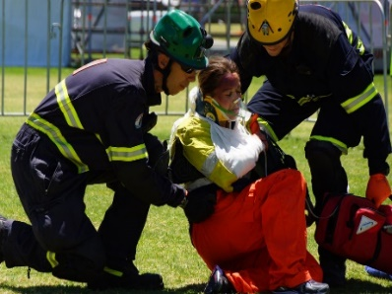 HLT41120 Certificate IV in Health Care
Photo courtesy of Department of Mines and Petroleum MERC COMPETITION (Proudly sponsored by DNA Kingston Training)

COURSE DESCRIPTION
This course is designed to provide the person who wishes to commence a career in providing emergency services support to the mining and industrial sectors and may be progressing from the Certificate II in Medical Service First Response. Suggestions Cert II Medical Services First Response Year 11 and Certificate IV in Health Care year 12.
The Certificate IV in Health Care contains 7 (Seven) units from DNA Kingston Training programme HLT21015 Certificate II in Medical Service First Response qualification, will be identified as credit transfer.
Pathway: On completion of the HLT41115 Certificate IV in Health Care only one (1) further unit is required to be completed to attain the HLT51015 Diploma of Paramedical Science along with160 hours of clinical, which leads to a unique pathway developed by DNA Kingston Training with Edith Cowan University (ECU) with 1,130 hours of advanced standing (including 80 clinical hours). Undergraduate Bachelor of Paramedicine at (ECU) Edith Cowan University.
Total number of units 16 = 9 Core units and 7 electives.
WHY CHOOSE THIS COURSE
This qualification is for individuals who demonstrate a natural empathy and are caring individuals who may have completed the HLT21020 certificate II in Medical Services First response. This qualification reflects the role of workers who provide emergency service in industry settings such as Mining. They provide assessment of injured patient and provide suitable life support.
This qualification reflects the role of workers who provide initial pre-hospital and out-of-hospital basic health care response and assessment to patients requiring urgent medical services. The provision of urgent clinical care includes providing basic life support.
To achieve this qualification, the candidate must have completed at least 80 hours of experience.
EXAMPLES OF EMPLOYMENT/CAREER OPPORTUNITIES:
The qualification applies to people working in a variety of roles including ambulance officers, patient transport officers, industrial medics and basic life support medics.
COURSE OVERVIEW
This course is ideal for students considering a hands on, practical course and looking for a career in high level health care or looking for pathways to University in Paramedicine. Certificate IV level, with direct entrance to some University Health Science programmes (English conditions may apply).
COST/FEE PAYMENT OPTIONS:
The cost of 6 term course Y 11 and 12, with no credit is $3,150 additional resource fee for modules and uniforms.
Government school parents pay schools, Private schools generally pay college direct, payment plans available.

SITE | FEES | RESOURCE FEES | COURSE DURATION | RTO | W/E HOURS REQUIRED
Belmont  Bunbury (BRTTC)  Mandurah | $3,150.  3 Terms or with  Credit  $2,400 | $190  Modules and uniform | 1 day / week over 3 or 6 terms depending on credit | DNA Kingston Training 6811 | 80 hrs of work experience requirements for this course.
HLTAID003 Provide First Aid This nationally recognized training Provide First Aid Course has been designed specifically to address the needs to provide a higher degree of education in medical emergencies in order to meet the demands of the Medical and Mining settings. Developed and delivered by DNA Kingston Training and Partner Red Earth Health who have extensive and relevant experience in Health, Education, Mining, Paramedic and many aspects of emergency response. By attending this course, you will learn all the necessary skills and knowledge you require to provide a first aid response, life support, management of casualty(s) - the incident and other first aiders, until the arrival of medical or other assistance. This course consists of 16 hours of face-to-face training specifically designed for VET for Secondary Students, assuming most attendees have not engaged in First Aid training prior. Please note Auspice services also available. Three Delivery options:
Delivery mode 1. Face-to-face delivery over 2 days at DNA Kingston Training:
- Classroom attendance (16 hours minimum)
- Delivery covering the required Performance Evidence, Knowledge Evidence and Assessment Conditions. Pre reading manual provided to Students.
- Power points and learning manual to be completed in class answering questions as under pinning pre requisite to commence the scenarios and practical roll playing. Knowledge evidence.
- Practical scenarios, roll playing demonstrated under workplace simulated conditions. Performance evidence.
- Final theory assessment completed.
- (Learning materials consist of: work book, manual and online access as required)
2 day delivery face to face
Tuition fee per student including workbooks manual and online access 2 day $120
Minimum numbers: 10
Delivery mode 2. Face to face delivery 1 or 2 day delivery at the school:
Should the school have a cohort of Students who would like to complete the First Aid in one day, prior reading and exercises can be completed online, Classroom attendance (8 hours minimum).
1 or 2 day face to face delivery
Tuition fee per student including workbooks manual and online access 1 day $70 – 2 day $120
Minimum numbers: 8
Delivery mode 3. Provide First Aid face to face, over 2 days with White Card added into the training delivery
CPCCWHS1001 Prepare to work safely in the construction industry (White Card) and HLTAID003 Provide First Aid
On successful completion exit 2 day training with White Card and First Aid unit attainments.
Should the school have a cohort of Students who would like to complete the First Aid and White Card over two days, reading and exercises will be completed in the Classroom attendance (16 hours minimum).
2 day face to face delivery Provide First Aid and White Card
Tuition fee per student including workbooks manuals and online access $195
Minimum numbers: 10
CPCCWHS1001 Prepare to work safely in the construction industry

If you intend to work in the Construction Industry in Australia, you need a Construction Induction card -“White Card". DNA Kingston Training is an Award winning Training Organization, registration with WorkSafe W.A. to issue the W.A. Construction Induction Training Card.
You will learn: Safe work practices, risk management principles, safety signage, use of personal protection, legislation terminology and your obligation as a safe worker in the Construction Industry in a caring and supported learning environment, with specialist support teachers in English and Numeracy training.
Outcomes This unit is required for anyone who wishes to work on, or enter any active work site in Infrastructure, Resources and Construction. Persons working in a 'construction' trade position whether full-time or contracting are required to hold a white card and have it in their possession on site. This course is mandatory for those intended for a work site within Australia.
Licensing requirements Applicants need to be 15+ to apply for this training. This WHS knowledge is mandatory for those intending to work on industry work sites in Australia. White Card training relates directly to the induction program as specified by Chapter 6 Construction work, Part 6.5 General construction induction training, Work Health and safety Regulation 2011

Learning outcomes
- Identify health and safety legislative requirements of construction work
- Identify construction hazards and risk control measures
- Identify health and safety communication and reporting processes
- Identify incident and emergency response

Course Delivery face to face (1 day) 9 a.m. - 3 p.m.

A.M. -You will be guided through the course with qualified lectures in face to face delivery with learning material to read through at the college or on site at your school. Activities and roll plays at the college or school are included, along with Power Point presentation reviews.
P.M - Preparation, discussions with your Lecturer and review session ready to sit the exam at the college with our support and guidance.
Other Training options The White Card can be delivered over two days (2) with Provide First Aid added or additional training WHS on site preparation and excursion added to the training to engage students.
Standard 1 day White card course $55 per student
2 day training with First Aid $195 per Student
Minimum numbers of 10 students
Payment required prior to commencement
Delivery available on site at schools, Bunbury, Mandurah, Belmont, Joondalup -DNA Kingston Training Colleges.
Contact us Auspice delivery also available
P 1300 855 503 |E admin@dnakingstontraining.edu.au |W www.dnakingstontraining.edu.au

Suggestions for pathways

Year 11 Courses |  | Year 12 Courses | Pathway | Pathway
Certificate II in Health Support Services |  | Certificate III in Health Services Assistance | Edith Cowan College  Diploma in Health Science | ECU Degree in Nursing or  Health Science enter 2nd year.  Work as a Health Services Assistant
Certificate III in Dental Laboratory Assisting |  | Certificate IV in Dental Assisting | Diploma of Dental Technology Apprenticeship | ECU entry (English conditions) or work as a Dental Assistant / Dental Lab Assistant
Certificate III in Health Services Assistance |  | Certificate IV in Allied Health | University entry  (English requirements) | work as a Health Services Assistance / Allied Health Assistant
Certificate III in Health Services Assistance |  | Certificate IV in Dental Assisting | University entry  (English requirements) | work as a Dental Assistant / Allied Health Worker
Certificate III in Health Services Assistance |  | Certificate IV in Ageing Support | University entry  (English requirements) | work as an Allied Health Worker / Aging support worker
Certificate III in Individual Support |  | Certificate IV in Ageing Support | University entry  (English requirements) | work as an Allied Health Worker Disability/Aging support worker
Certificate II in Medical Services First Response |  | Certificate III in Health Services Assistance | Edith Cowan College  Diploma in Health Science | ECU Degree in Nursing or  Health Science enter 2nd year
Certificate II in Medical First Response |  | Certificate IV in Health Care | Diploma in Paramedic Science with DNA Kingston Training or enter directly into ECU Paramedicine Degree programme  (English requirements)  Employment in the mining sector as an Emergency Worker | Receive credit to ECU Paramedic Science Degree programme  1,130 hours of advanced standing (including 80 clinical hours). Undergraduate Bachelor of Paramedicine at (ECU) Edith Cowan University.
Certificate IV in Allied Health |  | Certificate IV in Allied Health | University entry  (English requirements) | Work as Allied Health worker

Diploma of Nursing is to be developed by DNA Kingston Training over the coming year. Graduates from our programmes will have priority regarding entry and pathways. English requirements will be embedded in training.

Perth city location:
Belmont Campus Head Office
63 Abernethy Road
BELMONT WA 6104
Joondalup
2 Onslow place West Perth Club rooms
Joondalup Kennedya Dr Joondalup

Regional locations
BRTTC – Manea Senior College
Robertson Drive
BUNBURY WA 6230
Mandurah Campus
Endeavour Centre
Unit 6 & 7, 2D Peel St
MANDURAH WA 6210

Office hours
Monday to Friday: 8:30 am to 5.00 pm
Saturday and Sunday: Closed

Contacts
Email: admin@dnakingstontraining.edu.au
Website: www.dnakingstontraining.edu.au
Phone: 1300 855 503
International Phone: +61 8 9479 4870
Facsimile: +61 8 9479 4880
Postal Address PO Box 69, Belmont WA 6984

Additional per course information / introduction documents can be made available
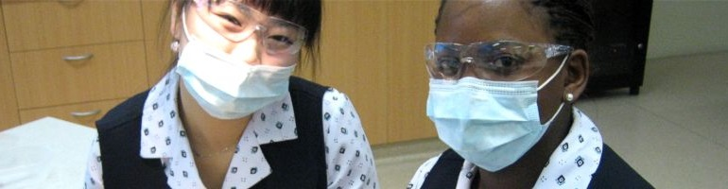
DNA Kingston Training is registered on the Auspice Provider Panel for the Education Department

Enrolment form attached for your convenience, online enrolment also available, www.dnakingstontraining.edu.au
COURSE SELECTION
Cert III in Individual Support- Dis /Comm CHC33015
Cert IV in Ageing Support CHC43015
Cert II in Health Support Services HLT23215
Cert III in Health Services Assistance HLT33115
Cert III Dental Assisting HLT35015
Cert IV in Dental Assisting HLT45015
Cert III in Career Enahncement 10585NAT
Cert III in Dental Laboratory Assisting HLT35115
Cert II in Medical Service First Response HLT21020
Cert IV in Allied Health Assistance HLT43015
Cert IV in Health Care HLT451120
CPCCWHS1001 Prepare to work safely (White Card)
HLTAID003 Provide First Aid

Training Location preference: Belmont Mandurah Bunbury Joondalup
Student Secondary School: ……………………………………………………………………….. Personal Details

Student Surname |  | Gender | M | F

Given Names
You are required to provide a copy of your passport or Birth Certificate
Date of Birth | / / | Email address

Residential Address
(No. & street)

Suburb / City |  | State |  | Post code

Phone number 1 | ( ) | Number 2 | ( )

Nationality

Student USI  Unique Student Identifier |  |  | MUST be recorded here before certificate can be issued.  http://www.usi.gov.au/Pages/
 |  | (Tick if applicable) | I do not have a USI number and would like DNA Kingston Training to apply for one on my behalf
Please complete and sign this form. By signing you agree that you will commit to the training programme enrolled and pay associated fees and follow the policies and procedures outlined by DNA Kingston Training, if under 18 years of age your Parent/Guardian will need to sign on your behalf
Applicants signature |  | Date

Guardian / Parent signature | ( ) | Date

Guardian / Parent name |  | Contact No  Email

Language and Cultural Diversity Government requirement details

1. In which country were you born?
Australia | 1101 | Other - please specify:

2. Do you speak a language other than English at home? (If more than one language, indicate the one that is spoken most often)
No, English only | 1201 |  | Yes, other - Please specify:

3. How well do you speak English?
Very well | 1 |  | Not well | 3
Well | 2 |  | Not at all | 4
- Are you of Aboriginal or Torres Strait Islander origin? For persons of both, mark both “yes” boxes
No |  | Yes, Aboriginal |  | Yes, Torres Strait Islander

Disability
- Do you consider yourself to have a disability, impairment or long-term condition?
Yes | Y | No | N
- If YES, then please indicate the areas of disability, impairment or long-term condition: (you may indicate more than one area)
Hearing/Deaf | 11 | Learning | 14 | Vision | 17
Physical | 12 | Mental Illness | 15 | Medical Condition | 18
Intellectual | 13 | Acquired Brain Impairment | 16 | Other | 19

Schooling
- What is your highest COMPLETED school level? (Tick ONE box only.)
Year 12 or equivalent | 12 | Year 10 or equivalent | 10 | Year 8 or below | 08
Year 11 or equivalent | 11 | Year 9 or equivalent | 09 | Never attended school | 02
- In which YEAR did you complete that school level?
- Are you still attending secondary school? Yes No

Previous Qualifications Achieved
- Have you SUCCESSFULLY completed any of the following qualifications?
Yes | Y | No | N
- If YES, then tick ANY applicable boxes.
Bachelor degree or higher degree | 008 | Certificate III (or Trade Certificate) | 514
Advanced Diploma or Associate Degree | 410 | Certificate II | 521
Diploma (or Associate Diploma) | 420 | Certificate I | 524
Certificate IV (or Adv. Certificate/Technician) | 511 | Certificates other than the above | 990

Employment
- Of the following categories, which BEST describes your current employment status? (tick ONE box only)
Full-time employee | 01 | Employed - unpaid worker in a family business | 05
Part-time employee | 02 | Unemployed - seeking full-time work | 06
Self employed - not employing others | 03 | Unemployed - seeking part-time work | 07
Employer | 04 | Not employed - not seeking employment | 08

Study Reason
- Of the following categories, which BEST describes your main reason for undertaking this course (Tick ONE box only.)
To get a job | 01 | It was a requirement of my job | 06
To develop my existing business | 02 | I wanted extra skills for my job | 07
To start my own business | 03 | To get into another course of study | 08
To try for a different career | 04 | For personal interest or self-development | 12
To get a better job or promotion | 05 | Other reasons | 11

