Application | Pre-Apprenticeships in Schools (PAiS)
for the MTA WA’s Automotive Institute of Technology
This course runs for 2 years over 7 terms.

Pre Apprenticeship
Certificate II in Automotive Vehicle Servicing AUR20516

Applicant Contact Details

Given Name: Surname:

Birth Date: Gender: Male Female Postal Address: Suburb: State: P/C: Street Address: Suburb: State: P/C: Phone: Mobile:
Email: USI Number:

Emergency /Parent Guardian Contact Details

Given Name: Surname: Relationship:
Street Address: Suburb: P/C: Phone: Mobile:
Email:

Supplementary Details (Completed by applicant.)

Emergency Medical Contact Name: Emergency Medical Contact Number: Medicare Number:
School Details (Completed by VET Coordinator)

School Name: Mindarie Senior College VET Coordinator: Tracey Loughnan

Year at School: Year 10 Year 11 Year 12 The student’s latest report has been attached

Postal Address: Suburb: P/C: Street Address: Suburb: P/C: VET Coordinator Phone: 9304 5813 VET Coordinator Mobile: 0422 255 487
VET Coordinator Email: tracey.loughnan@education.wa.edu.au

School Reference ( To be completed by VET Coordinator or Year Coordinator at current school)

We support this application and endorse the student as being “work ready” and meeting the academic requirements of the program

Yes No Yes with Reservation

Please provide comments in regards to the schools support or otherwise of this application:

School Signature: Date:

MTA WA’s Automotive Institute of Technology
www.mtawa.com.au | 9233 9800 | PO Box 1060, BALCATTA WA 6914 Version 6: 7 July 2017

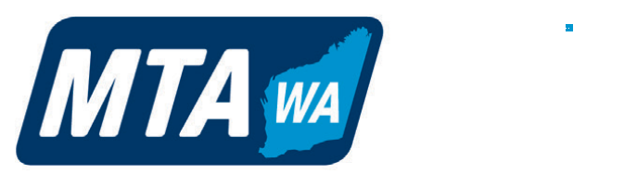
Application | Pre-Apprenticeships in Schools (PAiS)

About the Applicant (Completed by applicant.)

Have you done, or are you doing any work experience?

Why do you want to participate in this program?

Please outline your knowledge of and interest in the automotive industry.

What do you plan to do immediately after the conclusion of this course?

Photo Declaration
I hereby authorise the Motor Trade Association of WA (MTA WA) to publish photographs taken of me during the course of my studies at the MTA WA’s Automotive Institute of Technology, and my name and likeness, for use in the MTA WA’s print, online and video-based marketing materials, as well as other Association publications. I hereby release and hold harmless MTA WA from any reasonable expectation of privacy or confidentiality associated with the images specified above. I further acknowledge
that my participation is voluntary and that I will not receive financial compensation of any type associated with the taking or publication of these photographs or participation in MTA WA marketing materials or other Association publications. I acknowledge and agree that publication of said photos confers no rights of ownership
or royalties whatsoever. I hereby release MTA WA, its contractors, its employees, and any third parties involved in the creation or publication of marketing materials, from liability for any claims by me or any third party in connection with my participation.

If you are under the age of 18 please ensure that your application is signed by a parent or guardian in the space provided below.

Signature: Date: Name (Printed):
Parent/Guardian Signature: Date:
Name (Printed) Relationship:

Office Use Only
Received by: Date Received: Processed by: Date Processed:

MTA WA’s Automotive Institute of Technology
www.mtawa.com.au | 9233 9800 | PO Box 1060, BALCATTA WA 6914 Version 6: 7 July 2017

